**ASSIGNMENT 4**

Question #01

A program that takes input of integers repeatedly until user enters a zero digit then it prints the number of positive and negative integers.

SOURCE CODE

#include <iostream>

using namespace std;

int main()

{

int x,px=0,nx=0;

while (x!=0)

{

cout<<"Enter a number: "<<endl;

cin>>x;

if(x>0)

{

px+=1;

}

else if(x<0)

{

nx+=1;

}

}

cout<<"Positive numbers are: "<<px<<endl;

cout<<"Negative numbers are: "<<nx<<endl;

return 0;

}

OUTPUT

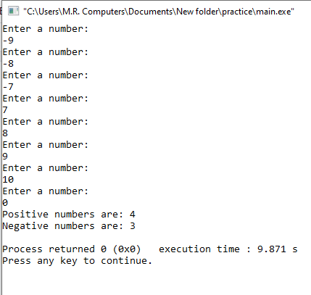

**Question #02**

Write a program in C++ to make such a pattern like right angle triangle using number which will repeat the number for that row. [Go to the editor](https://www.w3resource.com/cpp-exercises/for-loop/index.php#EDITOR)

Sample Output: **(Hint: Use Nested while-loop)**

SOURCE CODE

#include <iostream>

using namespace std;

int main()

{

int x=0,y;

while (x<=5)

{

while(y<x)

{

cout<<"*";

++y;

}

x++;

y=0;

cout<<"*"<<endl;

return 0;

}

OUTPUT

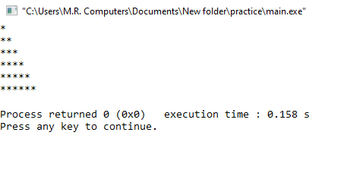

**Question #03**

Write a program in C++ to display the pattern using digits with left justified and the highest columns appears in first row in descending order. [Go to the editor](https://www.w3resource.com/cpp-exercises/for-loop/index.php#EDITOR)

Sample Output: (**Note: Use Nested do-while loop**)

Input number of rows: 5

5 4 3 2 1

4 3 2 1

3 2 1

2 1

1

SOURCE CODE

#include <iostream>

using namespace std;

int main()

{

int x=4,y,i,j,a=0;

do

{

y=0;

i=6;

i=i-a;

do

{

i--;

cout<<i;

++y;

}

while(y<=x);

a++;

--x;

cout<<endl;

}

while (x>=0);

return 0;

}

OUTPUT

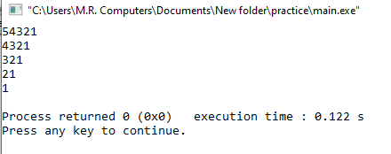

**Question**

**Write a program using both continue and break statement using any loop. This program starts**

**the counter from 2 to 25 and skip the values of 13, 16, and 19. This program must be terminated**

**when counter reaches**

SOURCE CODE

#include <iostream>

using namespace std;

int main ()

{

for (int x=2; x<=25; x++)

{

if (x==13||x==16||x==19)

continue; // jump to end of loop body

cout << x << endl;

if (x==23)

break;

}

return 0;

}

OUTPUT

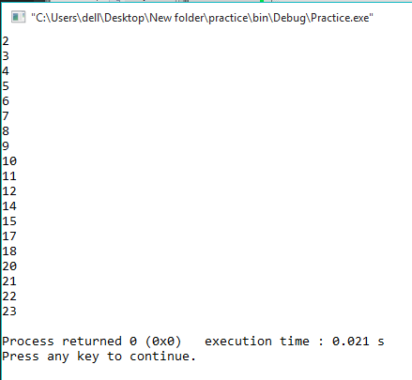

**Question #04**

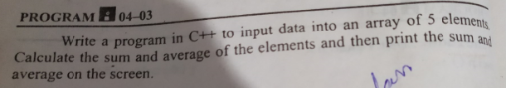

SOURCE CODE

#include <iostream>

using namespace std;

int main()

{

int a[4],b=0,c=0;

cout<<"Enter 5 numbers: "<<endl;

for(int x=0; x<=4; x++)

{

cin>>a[x];

}

for(int y=0; y<=4; y++)

{

b+=a[y];

}

c=b/5;

cout<<"The sum of the numbers is: "<<b<<endl;

cout<<"The average of the numbers is: "<<c<<endl;

return 0;

}

OUTPUT

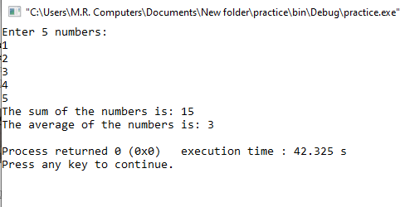

**Question #05**

Write a program which initializes 19 positive integer values in an array and print the 5th , 9th , 17th and 19th value and their sum.

SOURCE CODE

#include <iostream>

using namespace std;

int main()

{

int a[18],b=0,c=0;

cout<<"Enter 19 numbers: ";

for(int x=0; x<=18; x++)

{

cin>>a[x];

}

cout<<"The 5th number is: "<<a[4]<<endl;

cout<<"The 9th number is: "<<a[8]<<endl;

cout<<"The 17th number is: "<<a[16]<<endl;

cout<<"The 19th number is: "<<a[18]<<endl;

b=a[4]+a[8]+a[16]+a[18];

cout<<"The sum of the numbers is: "<<b<<endl;

return 0;

}

OUTPUT

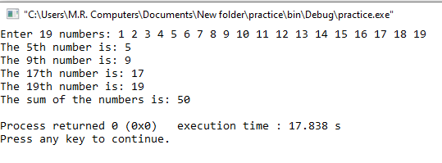

**Question #06**

Write a program that declares an integer array of size 10 and reads values from user in it. Then find out how many elements are even and how many are odd.

**Output:**   
*Enter values in array: 4 2 12 65 71 34 18 98 30 12*

*Even numbers are: 7*

*Odd Numbers are: 3*

SOURCE CODE

#include <iostream>

using namespace std;

int main()

{

int a[10],b=0,c=0,d=0;

cout<<"Enter 10 numbers: ";

for(int x=0; x<=9; x++)

{

cin>>a[x];

}

for(int y=0; y<=9; y++)

{

if(a[y]%2==0)

{

c+=1;

}

else

{

d+=1;

}

}

cout<<"Even numbers are: "<<c<<endl;

cout<<"Odd numbers are: "<<d<<endl;

return 0;

}

OUTPUT

